Iteration 3: Database Query Testing
To ensure the developed database meets the client’s requirements, a series of SQL queries were designed and executed. These queries validate the functionality, integrity, and relationships of the database structure
The testing process focuses on verifying three key areas:
- Data Retrieval (SELECT Queries)
These queries ensure that users can correctly retrieve stored information such as articles, categories, subjects, and related entities. This supports the student requirement of browsing articles by category and keyword search.
Requirement 1: Browse articles by category
SELECT
a.article_id,
a.title,
c.category_name,
s.subject_name
FROM articles a
JOIN categories c ON a.category_id = c.category_id
JOIN subjects s ON a.subject_id = s.subject_id
WHERE c.category_name = 'Biography';
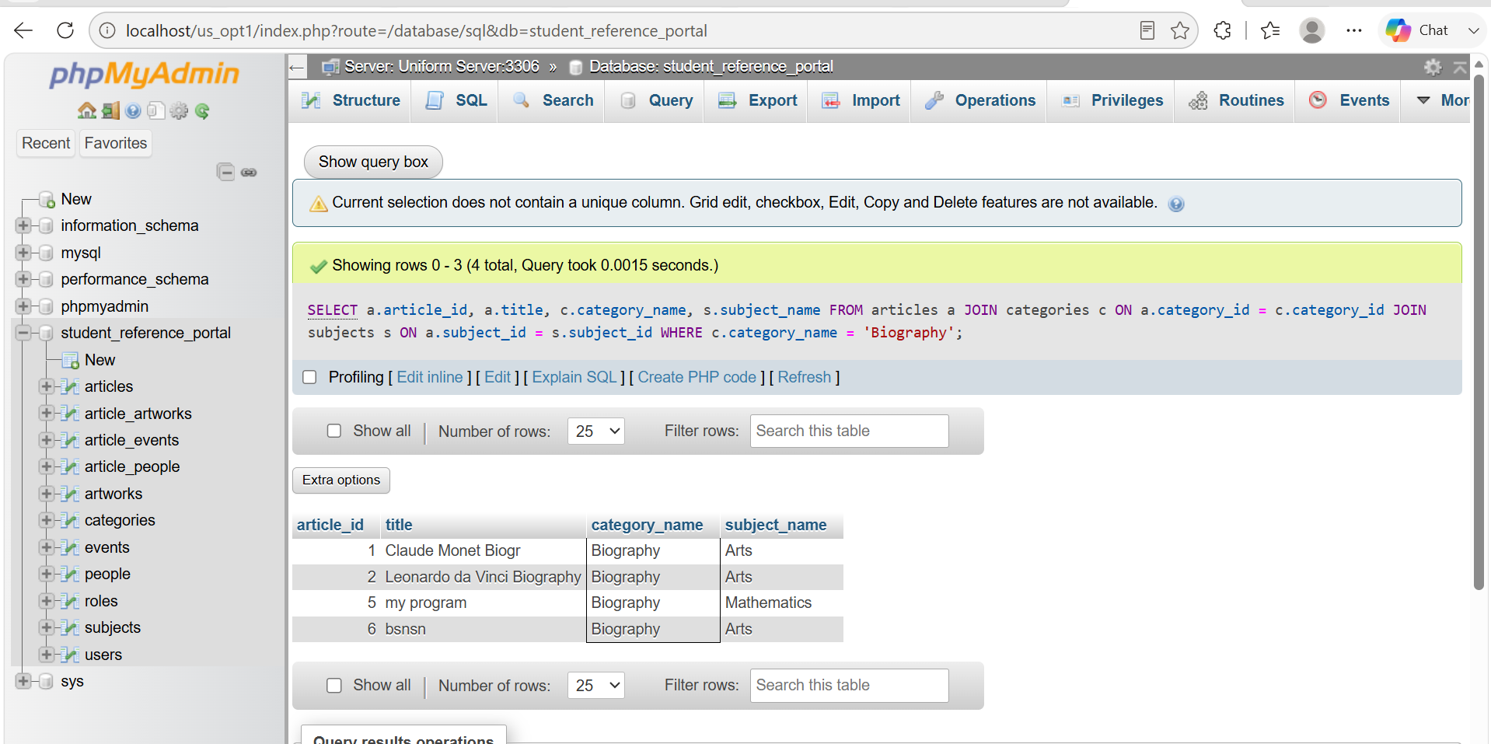

Requirement 2: Browse articles by keyword in title
SELECT
article_id,
title,
content
FROM articles
WHERE title LIKE '%Mona%';
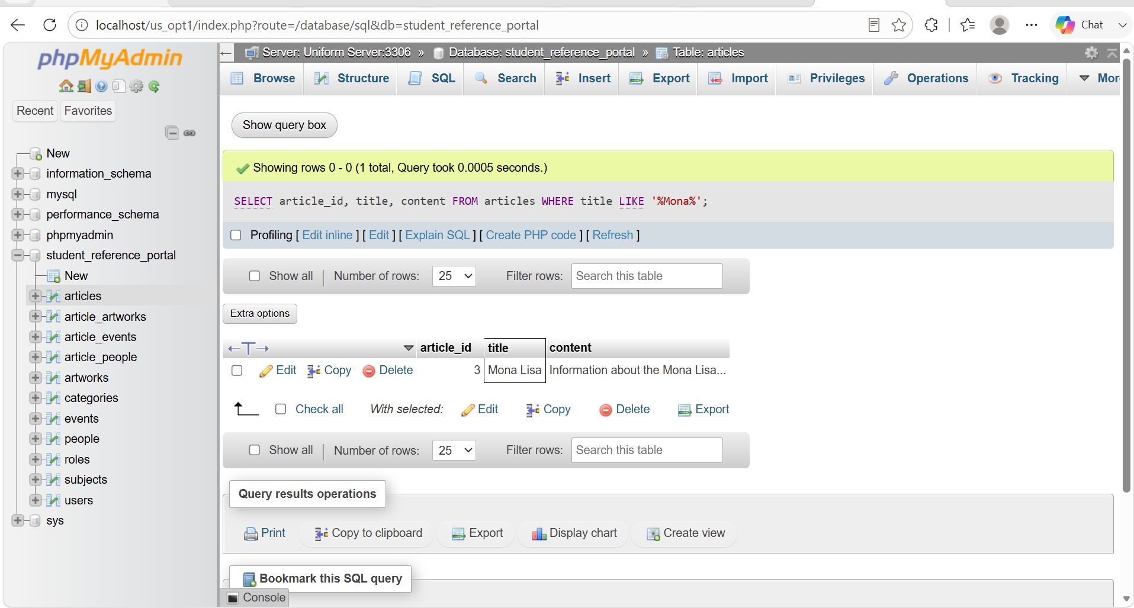

- Data Manipulation (INSERT, UPDATE, DELETE Queries)
These queries are used to test the ability of tutors and administrators to manage content within the system. Tutors are allowed to add and modify articles, while administrators have full control including deletion. This ensures role-based access control is correctly enforced at the database level
Requirement 1: Add or modify articles
INSERT INTO articles
(title, content, subject_id, category_id, created_by, status)
VALUES
('Test Article',
'This is a test article for database testing',
2, 2, 2, 'Published');
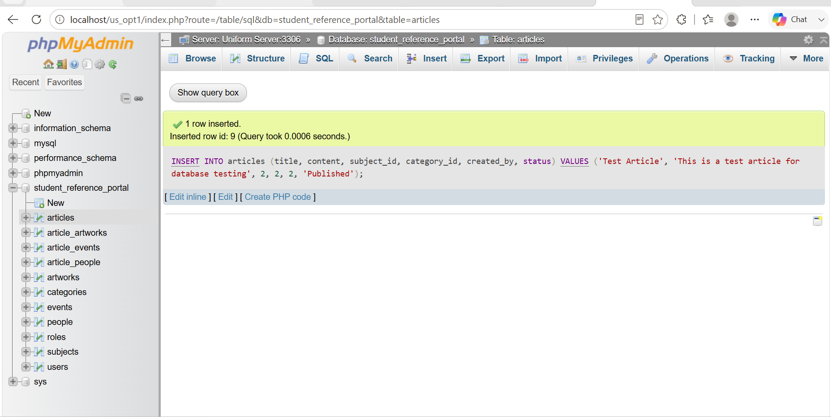

Requirement 2: UPDATE TEST QUERY (Modify Article)
UPDATE articles
SET title = 'Updated Test Article'
WHERE title = 'Test Article';
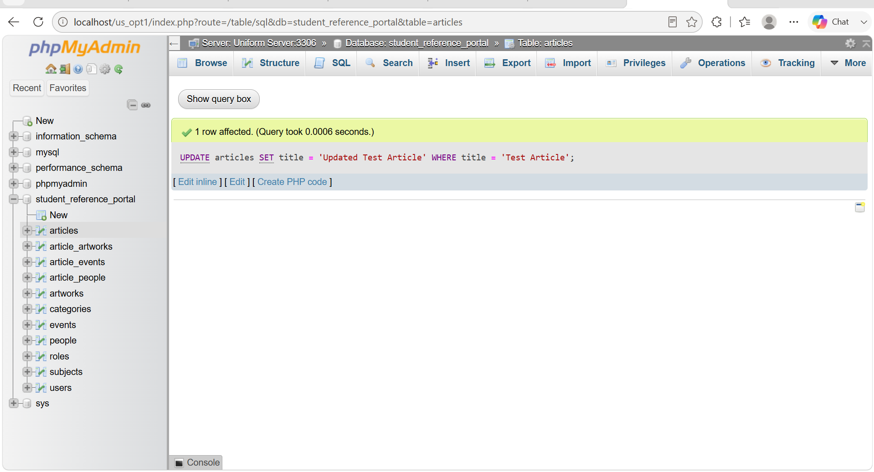

Requirement 3: Delete article
DELETE FROM articles
WHERE article_id = 3;
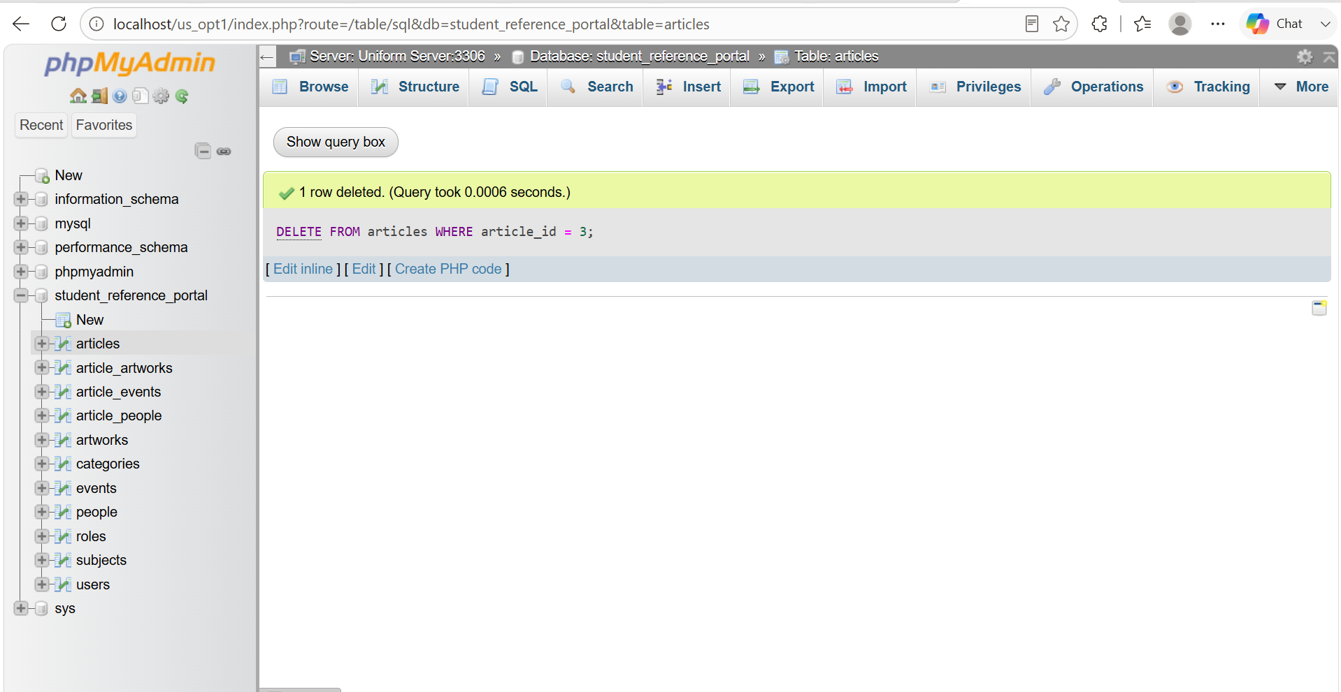

- Relational Integrity (JOIN Queries)
Complex JOIN operations are used to test relationships between multiple tables such as articles, people, events, and artworks. This confirms that the database is properly normalized and supports meaningful data relationships without redundancy.
Get full article details with people + artwork
SELECT
a.title,
p.name AS person_name,
ar.name AS artwork_name
FROM articles a
LEFT JOIN article_people ap ON a.article_id = ap.article_id
LEFT JOIN people p ON ap.person_id = p.person_id
LEFT JOIN article_artworks aa ON a.article_id = aa.article_id
LEFT JOIN artworks ar ON aa.artwork_id = ar.artwork_id;
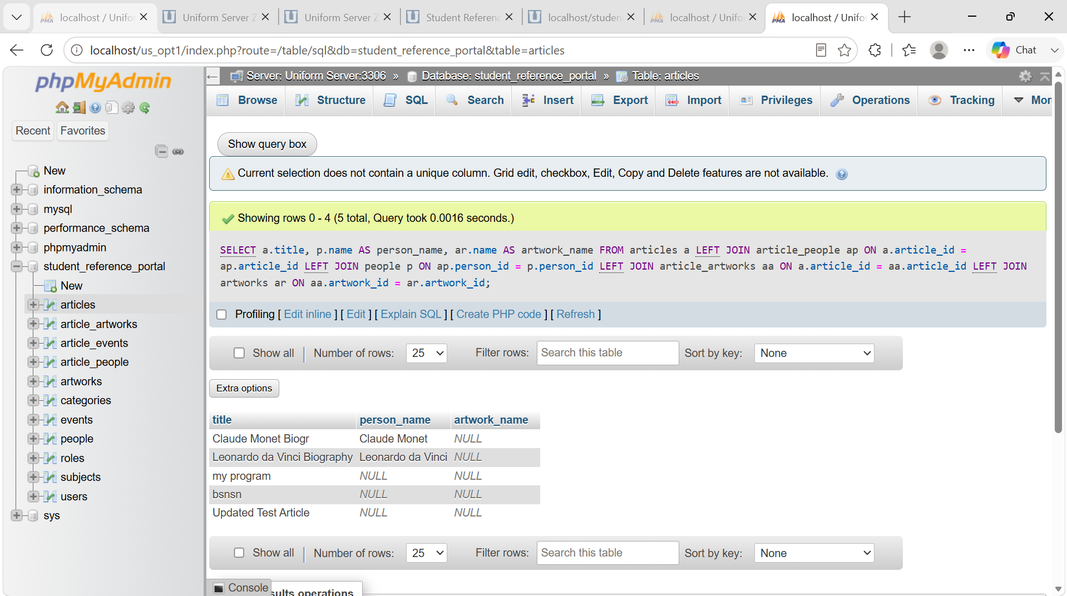

CATEGORY and SUBJECT FILTER TEST
SELECT
a.title,
s.subject_name,
c.category_name
FROM articles a
JOIN subjects s ON a.subject_id = s.subject_id
JOIN categories c ON a.category_id = c.category_id
WHERE s.subject_name = 'Arts';

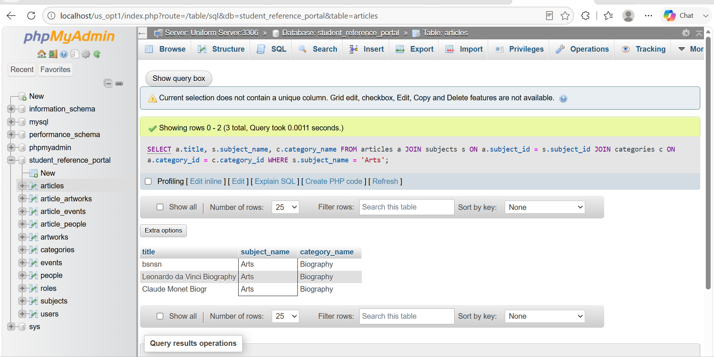

Overall, this testing phase validates that the database is fully functional, efficient, and aligned with the system requirements, ensuring accurate data handling and secure access control across different user roles.

